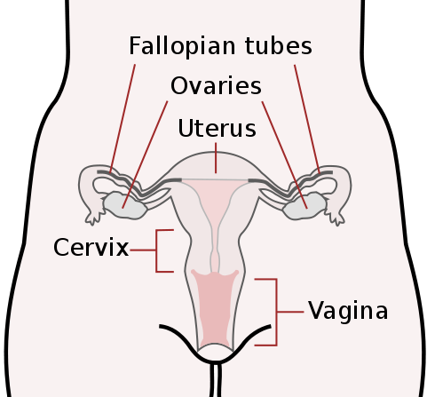
The Female Reproductive System
All living things reproduce. Reproduction — the process by which organisms make more organisms like themselves — is one of the things that sets living things apart from nonliving matter. Both the male and female reproductive systems are essential for reproduction. The female needs a male to fertilize her egg, even though it is she who carries offspring through pregnancy and childbirth.

Unlike the male, the human female has a reproductive system located entirely in the pelvis. A female's internal reproductive organs are the vagina, uterus, fallopian tubes, and ovaries.
THE VAGINA
The vagina is a ____________, hollow tube that extends from the vaginal ____________ to the uterus. The vagina is about 8 to 12 ____________ long in a grown woman. Because it has muscular walls, it can ____________ and ____________. This ability to become wider or ____________ allows the vagina to ____________ something as slim as a tampon and as wide as a ____________. The vagina's muscular walls are lined with ____________ mucous membranes, which keep it ____________.
The vagina serves three purposes:
- It's where the penis is inserted during sexual ____________.
- It's the ____________ that a baby takes out of a woman's body during ____________, called the birth canal.
- It provides the route for the ____________ blood (the period) to leave the body from the ____________.
THE CERVIX
The ____________ connects with the uterus at the cervix. The cervix has ____________, thick walls. The opening of the cervix is very small (no wider than a ____________). During childbirth, the cervix can ____________ to allow a baby to pass.

THE UTERUS
The uterus is a hollow, muscular organ in which a ____________ egg, called the "____________," becomes embedded and in which the egg is ____________ and allowed to develop until birth. It lies in the ____________ cavity behind the bladder and in front of the ____________. The uterus is lined with tissues which change during the menstrual ____________. The major tissues of the Uterus include the ____________ and the Myometrium.
Endometrium: Lining of the uterine cavity. In all ____________ mammals, including humans, the endometrium builds a lining ____________ which is shed if no pregnancy occurs.
Myometrium: The uterus mostly consists of ____________ muscle, known as Myometrium. This muscle has the ability to ____________ and exerts large amounts of force during child birth.
FALLOPIAN TUBES
The ____________ tubes connect the uterus to the ovaries. There are two fallopian tubes, each ____________ to a side of the uterus. The fallopian tubes are about 10 ____________ long and about as wide as a piece of ____________. Within each tube is a tiny ____________ no wider than a sewing needle. At the other end of each fallopian tube is a fringed area with ____________ called ‘fimbrae’ that look like fingers.
This fringed area wraps ____________ the ovary but doesn't ____________ attach to it. When an egg pops out of an ovary, it enters the ____________ tube via the aid of the ____________. Once the egg is in the fallopian tube, tiny ____________ in the tube's lining help push it down the narrow ____________ toward the uterus. The lining of the tube and its ____________ sustain both the egg and the sperm, encouraging ____________ and nourishing the egg until it reaches the ____________.
THE OVARIES
The ____________ are a pair of oval or almond-shaped ____________which lie on either side of the uterus and just below the ____________ to the fallopian tubes. In addition to ____________ eggs the ovaries produce female sex ____________ called oestrogen and ____________.

